February 25, 2025

The Honorable Anthony Brown
Maryland Attorney General
200 St. Paul Place
Baltimore, Maryland 21202

Dear Attorney General Brown,

We are writing to address an issue that is affecting our constituents who are residents of the Bel Air, Glen Oaks, and Rawlings communities in Allegany County.

These families have been subjected to unreasonable increases to their water and wastewater service bills by the Maryland Water Service Company. The increases were approved by the Public Service Commission (PSC) and took effect December 2024. Many of the bills have doubled with no significant increase in the amount of water consumption to these households.

Many of these residents appeared and spoke before the PSC and voiced their concerns to no avail. Several of these people are senior citizens living on fixed incomes and unable to continually absorb these skyrocketing increases.

Our constituents have also contacted the Office of People’s Counsel (OPC) for guidance; however, they have been informed the OPC did not have any suggestions under their purview.

Some have filed an online “General Consumer Complaint” concerning price gouging by the Maryland Water Service Company. It is our understanding the current backlog to investigate these complaints is at least two months.

Our ask of you is the following: we would like to elevate the investigation of our constituents’ complaints for the purpose of entering possible emergency legislation in the Maryland General Assembly’s 2025 session that concludes in April, if your office determines necessary.

Also, we would like to schedule a meeting with you to seek your advice on other avenues available to help the citizens in our district.

Sincerely,
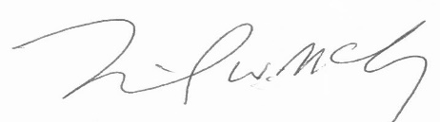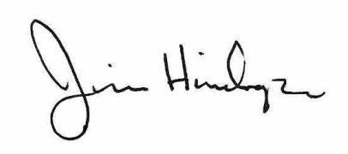

Senator Mike McKay Delegate Jim Hinebaugh
District 1 District 1A
Allegany, Garrett, and Washington Counties Allegany and Garrett Counties

